IP ADDRESSING TABLE
Device | IP address | Subnet mask | Default gateway | DNS server
Admin PC | 192.168.10.101 | 255.255.255.0 | 192.168.10.1 | 192.168.10.2
Project PC | 192.168.10.111 | 255.255.255.0 | 192.168.10.1 | 192.168.10.2
CAD PC | 192.168.10.121 | 255.255.255.0 | 192.168.10.1 | 192.168.10.2
Visual PC | 192.168.10.131 | 255.255.255.0 | 192.168.10.1 | 192.168.10.2
DNS Server | 192.168.10.2 | 255.255.255.0 | 192.168.10.1 | 192.168.10.2
Office Server | 192.168.10.10 | 255.255.255.0 | 192.168.10.1 | 192.168.10.2
Router office interface | 192.168.10.1 | 255.255.255.0
Router external interface | 203.0.113.1 | 255.255.255.0
Cloud Server | 203.0.113.10 | 255.255.255.0 | 203.0.113.1 | 192.168.10.2
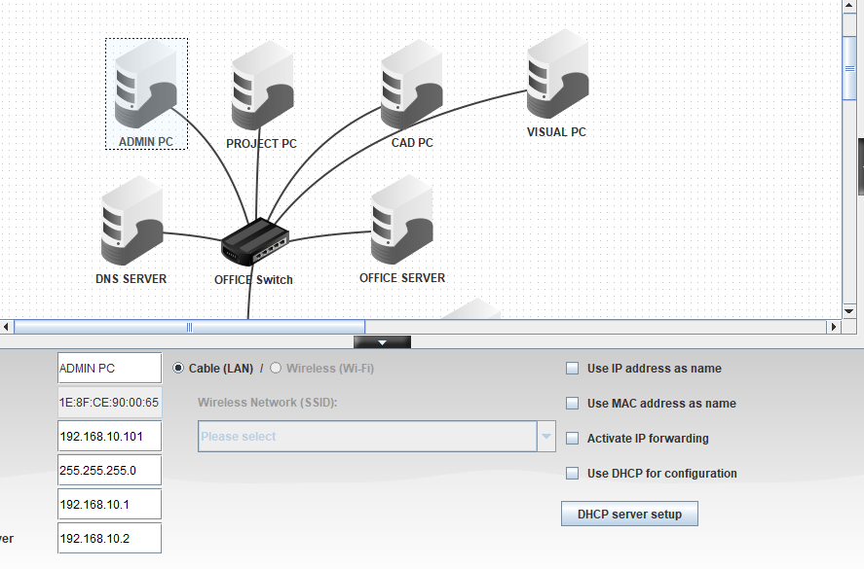
CAD IP
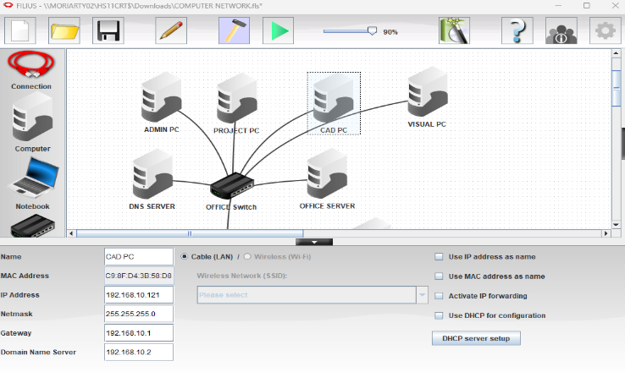
DNS IP
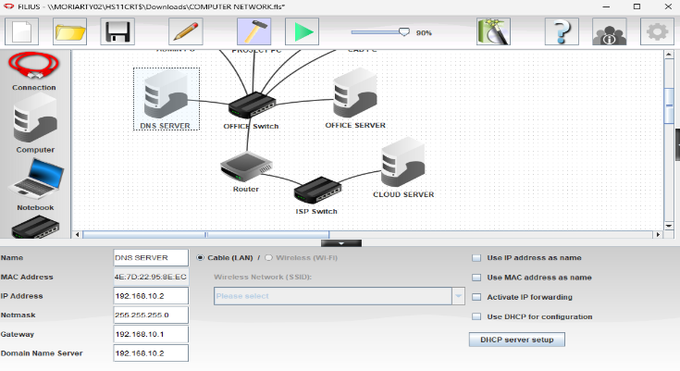
PROJECT IP
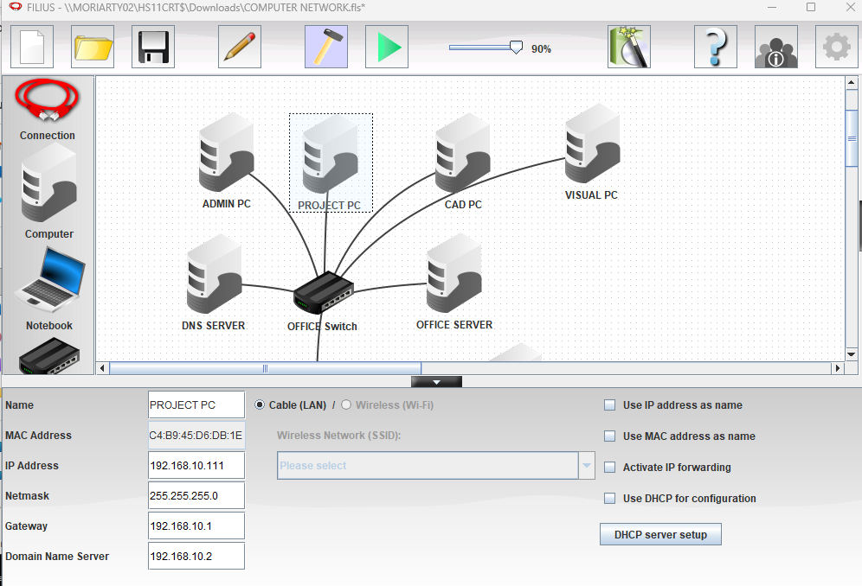
OFFICE IP
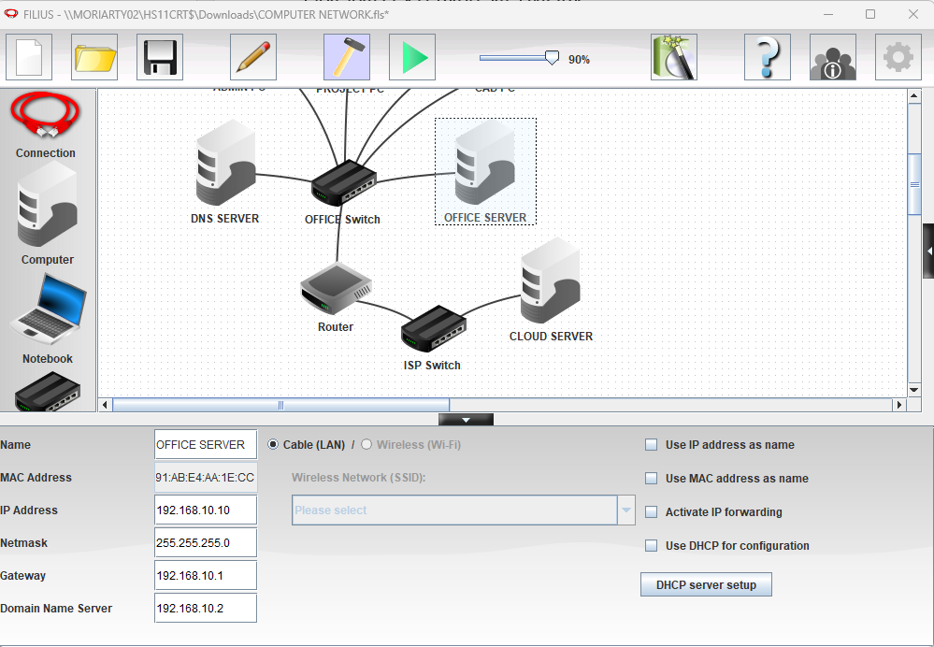
CLOUD IP
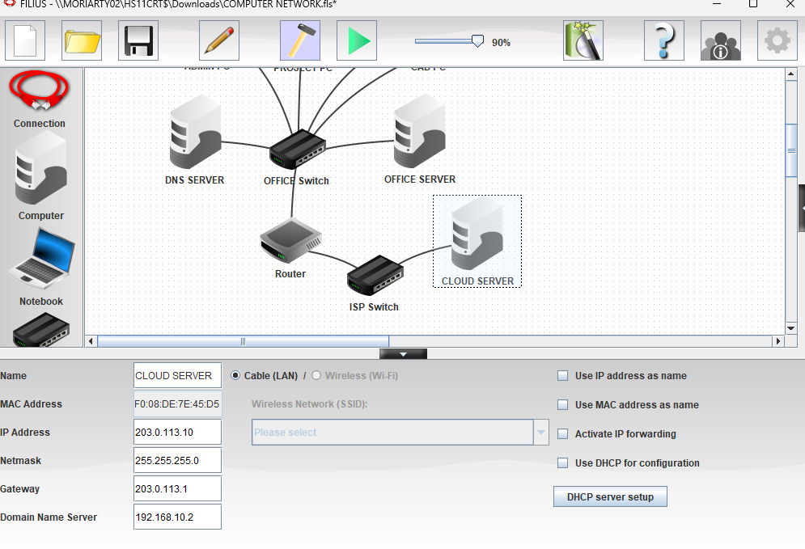
DNS RECORD
Website name | IP address
intranet.archstudio.local | 192.168.10.10
cloud.archstudio.example | 203.0.113.10

PROTOCOLS
Protocol | description
IP | Provides logical addresses so packets can be sent to the correct device or network.
DNS | Finds the IP address associated with a website name.
HTTP | Let’s a web browser request website content from a web server.
ICMP | Used by ping to test reachability and report network errors.
Ethernet | A common technology used to send data across a wired local area network.
TCP | Provides reliable, ordered delivery of data between applications.
Default gateway | The router interfaces a device uses to send traffic to other networks.

LAN AND EXTERNAL NETWORK
The LAN connects the devices inside the office, including four PCs, a DNS server and an office web server. These devices use IP addresses within the 192.168.10.0/24 network. The switch connects them so they can communicate, while the router provides access to the external network.
CLIENT-SERVER MODEL
The client-server model is where one device requests a service and another provides it. In this project, the CAD PC acts as the client when it opens a web page in a browser. The Office Server provides the internal company page, while the Cloud Server provides the external cloud page. The DNS server translates website names into IP addresses so the PC can find the correct server.

Test | Command | Actual result
Ping Admin PC | ping 192.168.10.101 | 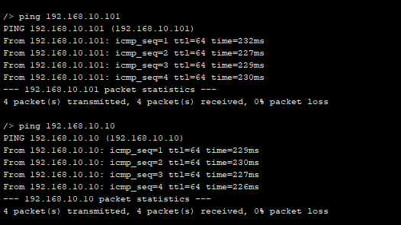
Ping Office Server | ping 192.168.10.10
Ping DNS Server | ping 192.168.10.2 | 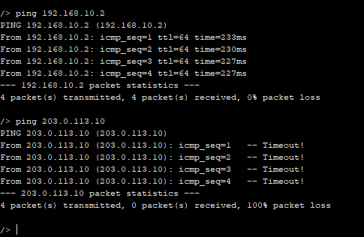
Ping Cloud Server | ping 203.0.113.10
Internal website | http://intranet.archstudio.local | 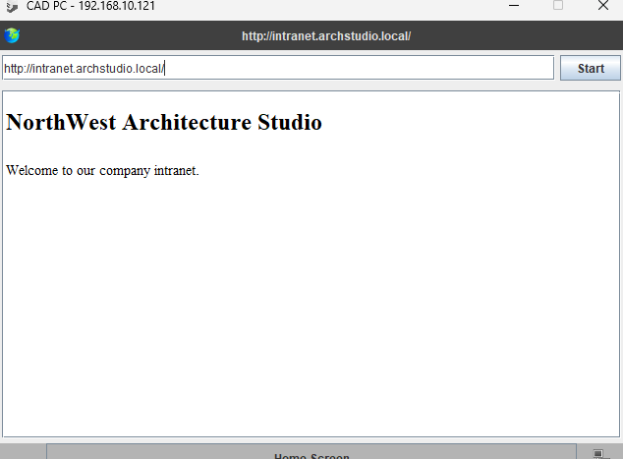
External website | http://cloud.archstudio.example | 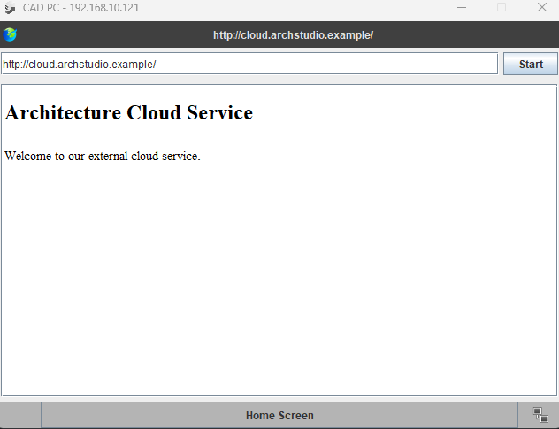

NETWORK TOPOLOGY
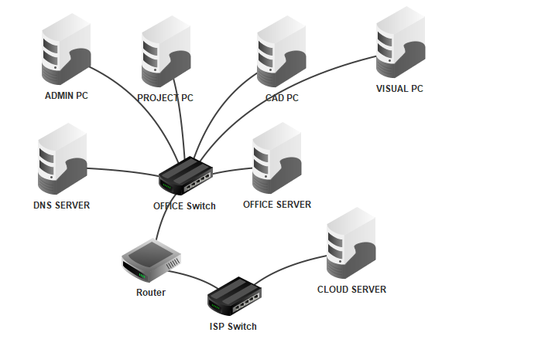
ROUTER INTERFACE
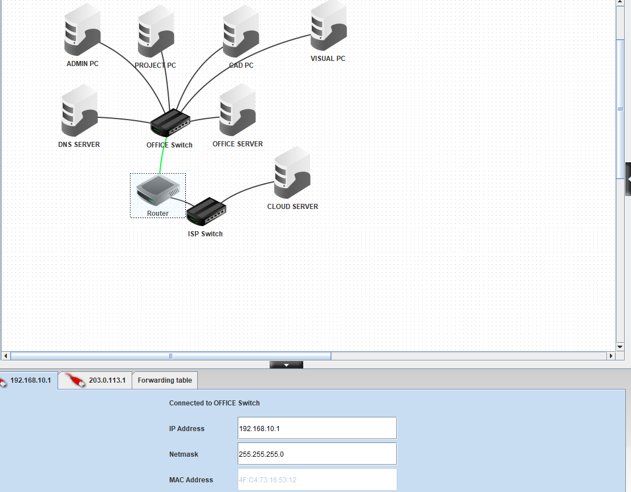
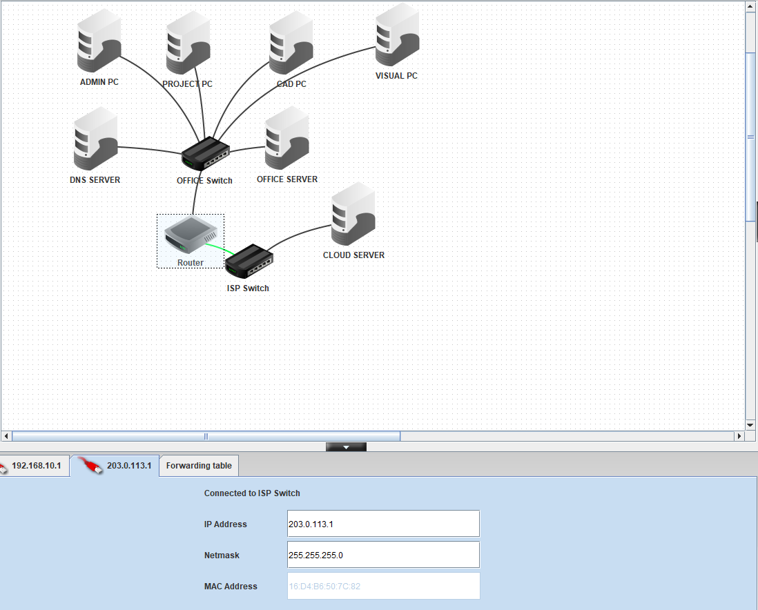
PING TEST

